**Moving forward through THE EPIC ROAD**

1. I stand ***amid a jagged series of peaks***, ***enveloped*** in a ***haze*** that ***tinges*** both the rocks and the sky an unusual ***shade*** of Mars***.*** I might indeed be ***tricked into*** believing I'm on another planet altogether, ***were it not for*** the ***strip of road that winds through the center of the valley*** and reminds me that others have ***traced their way into the depth***s of this place before me. (这段描写有什么特色) 翻译本段

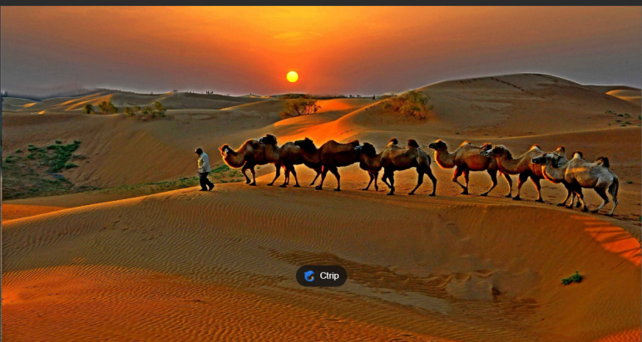

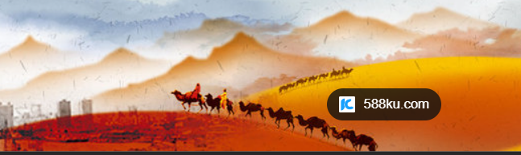

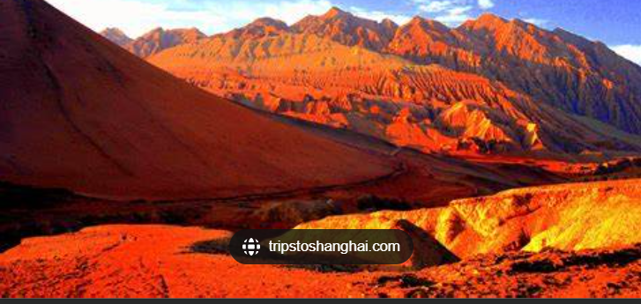

***我站在嶙峋的山峰之间。薄雾轻笼，岩石和天空都带着非同寻常的火星般的红色***。***要不是***有***一条穿过山谷中心的蜿蜒小路***提醒我，在我之前也曾有人***踏足这片土地的深处***，我可能真的***会误以为***自己完全是在另一个星球上

1. One of the first Europeans to ***set sail for t***hese lands was the ***legendary explorer*** and writer Marco Polo, who ***journeyed far from his own country*** and ***into Yuan Dynasty-era China*** in 1275. "I did not write half of what I saw, for I knew it would not be believed," he wrote in his ***memoirs*** of the period.

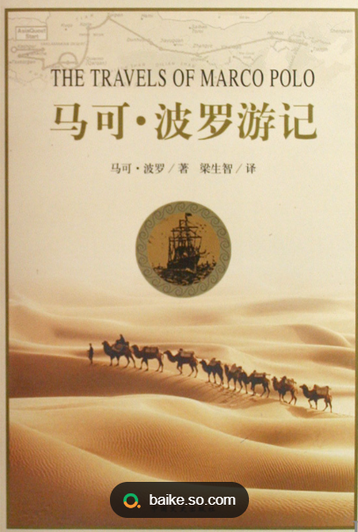

1. Like ***our journey through millennia of evolutionary changes***, the Silk Road is a trip that is considered important to the human condition. It may not be the first story of human movement, recorded or ***otherwise***, but it is perhaps the most ***abiding***. The Silk Road was a series of trade routes that began thousands of years before the ***Common Era*** and lasted until the 15th or 16th century (though many scholars argue that it continued for much longer). ***Over the millennia***, as ***kingdoms rose and collapsed*** and conquerors ***redrew*** broad areas of what is now Central Asia, the Middle East and Southern Europe, the route ***swerved and shimmied***, crossing mountains and deserts and eventually even the sea. ***Heading*** west from the ancient city of Chang'an (now Xi'an) in China ***trundled caravans*** of silk, tea, paper, and spices, ***inching toward t***heir destinations in Rome or Constantinople; heading east came glass, gold, silver and horses. The route was some 4,000 miles, and dangerous; the people who traveled along it knew that they could be ***felled by perils both human and climatic,*** that at any moment, the lands they ***traversed*** could become ***hostile territory.***

|  |  |
| --- | --- |
| used to state what the result would be if sth did not happen or if the situation were different 否则；不然 | My parents lent me the money. Otherwise, I couldn't have afforded the trip.  We're committed to the project. We wouldn't be here otherwise. 否则我们就不会到这里来了。 |
| apart from that 除此以外 | There was some music playing upstairs. Otherwise the house was silent. 除此以外，房子里静悄悄的。  He was slightly bruised but otherwise unhurt. 他除了一点青肿之外没有受伤。 |
| in a different way to the way mentioned; differently 在其他方面；另；亦 | Bismarck, otherwise known as ‘the Iron Chancellor ’俾斯麦，亦称为“铁血首相”  It is not permitted to sell or otherwise distribute copies of past examination papers. 不准出售或以其他方式散发过去的试卷。  You know what this is about. Why pretend otherwise (= that you do not) ?为什么装作不知道？  I wanted to see him but he was otherwise engaged (= doing sth else) . 但他正忙着别的事情。 |
| ***及其他；或相反；或其反面 You use or otherwise or and otherwise to mention something that is not the thing just referred to or is the opposite of that thing.*** | ***● It was for the police to assess the validity or otherwise of the evidence...***  ***应该由警方来判定证据有效与否。*** |

● The decorations for the games have lent a splash of colour to an otherwise drab city.

为运动会所作的装扮给原本毫无生气的城市增添了一抹亮色。

● ...a blue and gold caravan, slightly travel-stained but otherwise in good condition.

除了在旅途中弄得有点脏以外，性能良好的蓝金色旅行拖车

● Take approximately 60mg up to four times a day, unless advised otherwise by a doctor...

每次服用大约60毫克，每天最多4次，或遵医嘱。

● There is no way anything would ever happen between us, and believe me I've tried to convince myself otherwise...

相信我，我已经努力试图说服自己我们之间存有希望，但我们真的是绝对不可能的。

● He didn't want company, talkative or otherwise...

他不想跟人搭伴，不管这个伴儿是否健谈。

inch

[+ 副词或介词短语] to move or make sth move slowly and carefully in a particular direction （使朝某方向）谨慎移动

[单独使用的动词] She moved forward, inching towards the rope. 她小心翼翼地慢慢向绳子挪过去。

[动词 + 名词短语] I inched the car forward. 我开着车小心地缓缓前行。

He inched his way through the narrow passage. 他一点一点地穿过狭窄的通道。

1. And so why did they persist, these early travelers? For one thing, there was their curiosity, ***their craving for the new***, as fundamental to our condition as hunger or thirst （analogy）. It wasn't just new objects or technologies that they encountered on the route; it was new ideas, new philosophies and new cultures（什么修辞）. To travel was to risk not only physical danger, but a different kind of risk as well — the chance that you might discard what you'd always believed for some other ideology altogether. The road could change you so profoundly that you might never again be welcomed back home.

crave

● There may be certain times of day when smokers crave their cigarette...

● You may be craving for some fresh air. 你可能很想呼吸呼吸新鲜空气。

She has always craved excitement. 她总渴望刺激。

I must crave your pardon. 我必须恳求您原谅。

1. For another, there was the ***allure of adventure***. Yes, the path was dangerous. Yes, you might never see your family again. But movement is also ***intrinsic to the human experience.*** It is why ***the romance of the Silk Road endures all these years later:*** Although you can ***interpret it as the first, most durable experiment in globalization***, you can also ***see it as a testament to not just our desire, but our need to explore***. Every traveler who leaves home therefore ***follows in the spirit of our Silk Road ancestors***, ***stepping out of our known world i***n the hope that we might be ***dazzled***.

[6] I had always been tempted by the same desire for adventure and exploration. And so this May, I arrived in Gansu Province to ***retrace a small part of Polo's epic route***, voyaging from the city of Lanzhou to ***the Buddhist grottoes of Dunhuang***.

[7] I ***drifted through*** wide rivers and ***scenic rock formations***, encountered beautiful oasis cities, listened to ***sand dunes*** sing and ***lost myself in rainbow-ridged mountains (此句为何吸引人)***. I also passed construction sites, ***bustling neighborhoods*** and trucks ***speeding on superhighways*** ***stretching for thousands of kilometers westward,*** which is part of "the New Silk Road." Sometimes it seemed like I w***as being catapulted back in time*** — at others, ***forward into a dazzling future land***.(翻译本段)

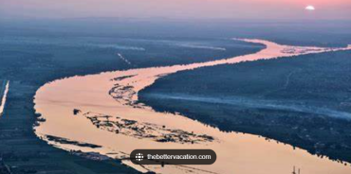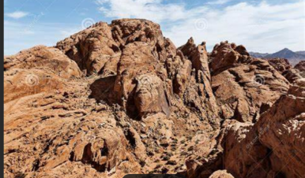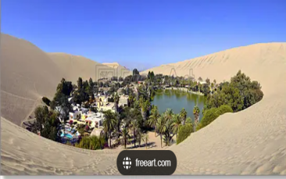

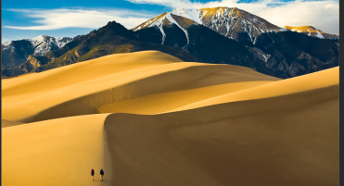

我***蹚过***宽阔的河流，途经***风景优美的岩石地貌***，邂逅美丽的绿洲城市，聆听***沙丘***的歌唱，***沉醉于有着彩虹山脊的山脉***。我还经过了建筑工地、***熙熙攘攘的街区***和***高速公路上奔驰***的卡车。这条高速公路***往西绵延数千公里***，是“新丝绸之路”的一部分。有时候，我好像***穿越到了过去***；有时候，又好像***穿越到了一个令人眼花缭乱的未来世界***。

1. And toward the end of my trip, I realized that the Silk Road has more lessons to offer us in this moment than I'd previously thought. While it is ***a reminder of our desire for interconnectedness***, it is also a reminder that open borders and movement bring wonder and awe to our lives, although they may also be accompanied by hardships and sorrows. ***Over the course of the Silk Road's operation***, humanity had to ***contend with some of the toughest challenges in recorded history.*** The journey was hazardous, ***the risks, geographical or political, were numerous***, and ***the dangers were deadly serious***. Travelers struggled with ***bleak deserts, formidable mountains***, and harsh weather. They also faced robbery, starvation, and ***other forms of deprivation.*** Numerous travelers lost their lives along the way, never being able to ***reunite*** with their family and friends.

reminder

~ (of sb/sth) | ~ (that…) something that makes you think about or remember sb/sth, that you have forgotten or would like to forget 引起回忆的事物；提醒人的事物

The sheer size of the cathedral is a constant reminder of the power of religion.使人时刻领略到 The incident served as a timely reminder of just how dangerous mountaineering can be.及时地提醒

The British are about to be given a sharp reminder of what fighting abroad really means... 清楚意识到

Violence has broken out in the capital, a stark reminder that the religious tensions are refusing to go away. 严酷的提醒

border on sth

|  |  |
| --- | --- |
| to come very close to being sth, especially a strong or unpleasant emotion or quality 濒于；近乎 | She felt an anxiety bordering on hysteria. 她感觉到一种近乎歇斯底里的焦虑。 |
| to be next to sth 挨着；接壤 | areas bordering on the Black Sea 黑海沿岸地区 |

[9] But for all these hardships and sorrows, the journey continued. Trade continued. Exchanges among different civilizations continued. The need to discover new things and new people, to ***look down the road*** ahead, continued. What else could they do, those pioneering travelers? They could ***no more*** ignore what they desired ***than*** they could ***unlearn what centuries of exploration and interaction had taught them***. （什么修辞？） ***The only way through*** （什么修辞？）was forward.

[10] It is the same for us today. The only way through is forward. Let us find some comfort, though, in the knowledge that ***we are preceded by centuries of human endurance***, by those travelers who remind us that the journey, no matter how difficult, ends up ***as an epic road worth taking***.

end up (尤指经历一系列意外后)最终处于，到头来;

If you go on like this you'll end up in prison.

I ended up doing all the work myself.

If he carries on driving like that, he'll end up dead.

The result was that the engine ended up at the bottom of the canal.

She fled with her children, moving from neighbour to neighbour and ending up in a friend's cellar. 最后逃到了一个朋友的地下室

If you don't know what you want, you might end up getting something you don't want.

Every time they went dancing they ended up in a bad mood.. 不欢而散